|  |
| --- |
| **Lab 7** |
| Report |
|  |
| NC – Saad Masood NC – Hafiz Manan |
|  |
| **bs16a-saad** |
| **3/20/2012** |
|  |

1. **Will the following code jump to the label named Target?**

**Mov ax, 81**

**cmp AX, 26h**

**jg Target**

**Ans:** Yes, the code jump to the label named Target.

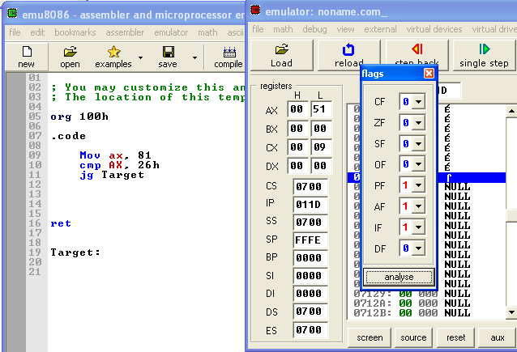

In this code destination > source which mean ZF=0,CF=0. Above window shows this.

1. **Will the following code jump to the label named Target?**

**Mov ax,-30**

**cmp ax,-50**

**jg Target**

**Ans:** Yes, the code jump to the label named Target.

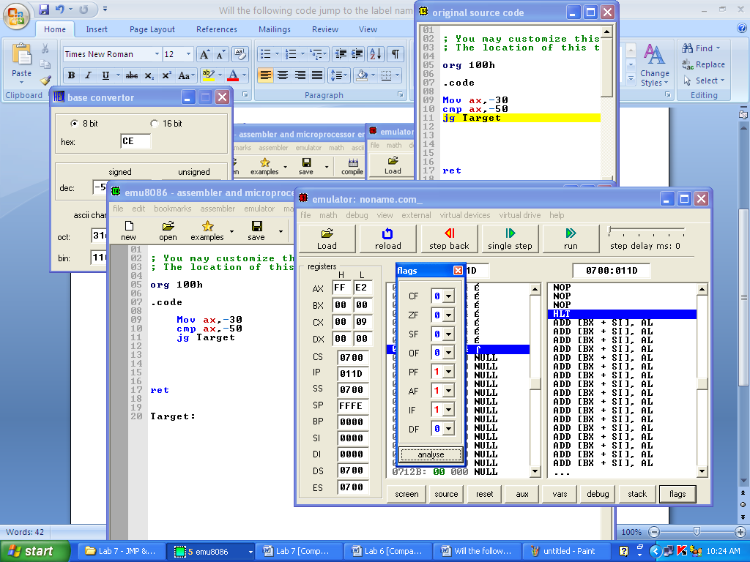

In this code destination > source which mean ZF=0,CF=0. Above window shows this.

1. **Will the following code jump to the label named Target?**

**Mov ax,-42**

**cmp aX,26**

**ja Target**

**Ans:** Yes, the code jump to the label named Target.

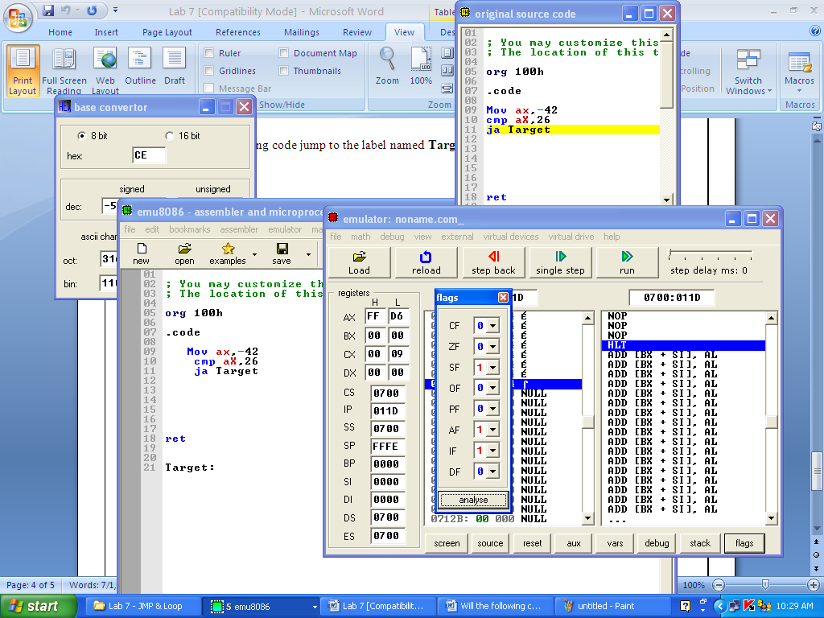

In this code destination > source which mean ZF=0,CF=0. Above window shows this.

1. Write a program to add first ten numbers. The result should be stored in register bl.

Ans: Program code is given in emu8086 window. Red box shows code

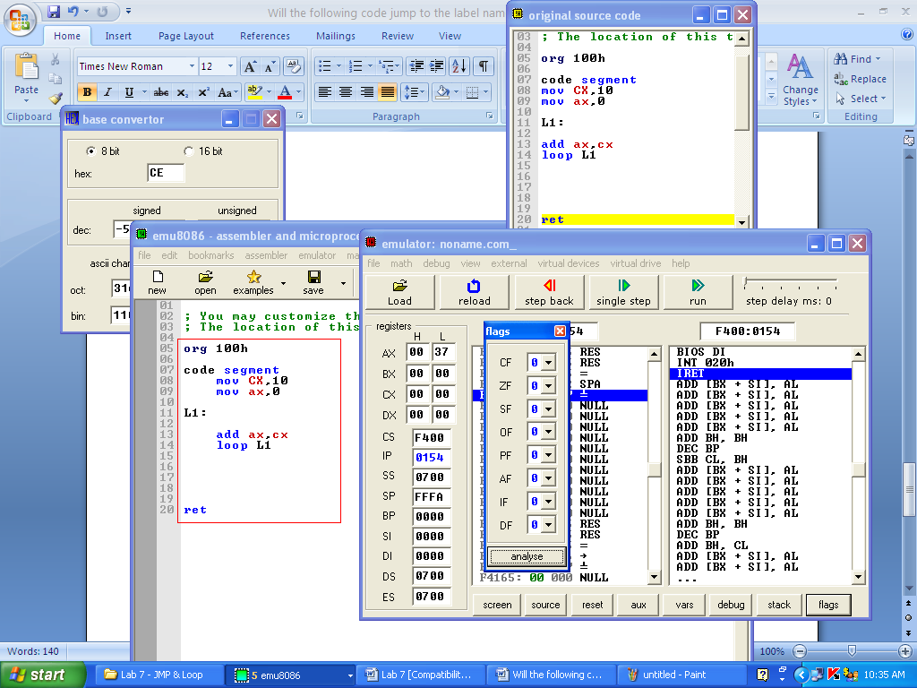

1. **Consider the following data:**

**List1: 10, 20, 30**

**List2: C2, D4, E5**

**Write a program that first calculates sum of list1 and then list2. Store results on different registers.**

**Ans:** Program code is given in emu8086 window. Red box shows code

